Lab 7 Assignment
Task 1:
The task here was to perform sentiment analysis on Twitter streaming data. I performed the following steps to complete the task.
- Create Twitter stream using Twitter4j package.
- Filter the Tweets where the language is English.
- Extract only the Tweet text from the Tweet.
- For every Tweet text perform sentiment analysis using the Stanford NLP class.
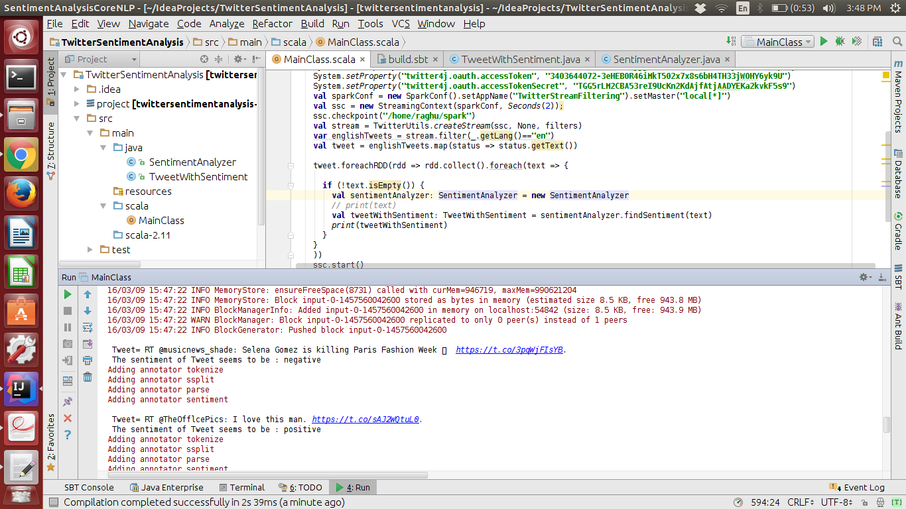
- Output the Tweet Text along with the sentiment of the Tweet text.

Task 2
This task was to suggest recommendations to the user based on his ratings for music genres. The following steps were performed to complete the task.
- Create training data through Twitter stream filtering and classification of data.
- Manually formatting the collected data into the desired format.
- Performing collaborative filtering on the training data to train the model.
- Get sample data from Twitter to serve as test data.
- Perform recommendation for the test data

